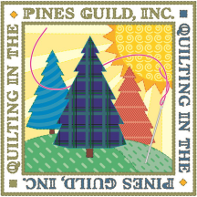
Quilting in the Pines Guild, Inc.
Membership Form
March 2026 – February 2027
Dues: $30
Annual membership expires at the end of February. Renewal for one year is $30. Please fill in the information below.

Enclose cash to this form, or attach your check for $30 payable to Quilting in the Pines Guide, INC. or Zelle- PinesQuilts@gmail.com Please note it is for membership.

Turn in at the meeting or mail it to:
Paula Wilson
7670 Atlanta Street
Hollywood, FL 33024

----------------Membership Information: (Please print legibly)--------------

Name: ______________________________________________

Address: ______________________________________________

______________________________________________

Phone: _________________________B-day (month/day)_______

Email: ______________________________________________

Any other information we should be aware of: ___________________

QUIP has permission to post pictures that might include me on social media (Facebook, Website, Newsletters)
YES / NO, Quip has my permission to post on social media.
Signature:_______________________________Date:___________

